# M8: Exam Preparation (Practice)

### Main goal

You are expected to utilize all or most of the studied products and technologies and create an infrastructure with **three** hosts. Their parameters are up to you to decide

The **emphasis** should be on **features** usage **demonstration** versus optimal solution

The goal is to have the whole **infrastructure** as a **file** or **set** of **files**. Then on top of it to create an **automated** **build** **process** which will wait for a hook call by the **source control system** and if there is a change in the project then all related images should be **re-build** and **re-run**

Your solution should look like

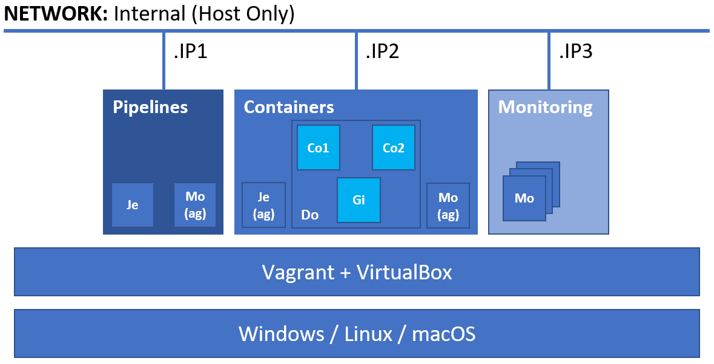

**All** **hosts** should be **provisioned** and **configured** in an automated fashion by utilizing **both** **Vagrant** and **bash** scripts

### Rules

Be sure to **follow** the **naming** **conventions** specified in the checklist and in project source files

The tasks execution order should not be derived from the order in which they are listed below. Please note that there are tasks that depend on the successful completion of one or more other tasks

If there are any manual steps, you must describe them in a free form (including commands if any) in an additional document. Don’t forget to include some pictures of the important (according to you) steps and of the **result** as well

### Tasks

#### Infrastructure (12 pts)

*You are expected to demonstrate knowledge working with* ***Vagrant*** *and* ***VirtualBox***

* (T101, 2 pts) Infrastructure with **three** machines
* (T102, 2 pts) All machines named according to the following convention:
  + The word **vm** combined with the **last part of the IP address** of the host and then the **domain part** (**do1.exam**)
  + For example, for the machine with IP address ***192.168.150.100***, the name will be ***vm100.do1.exam***
* (T103, 2 pts) All hosts in a dedicated network - **192.168.150.0/24**
* (T104, 2 pts) All necessary ports forwarded to the corresponding ports on the host machine, starting from **8080**. For example, **CI/CD** 8080 => **8080** on the host, **Containers** 8080 => **8081** on the host, and **Monitoring** *(depends on the solution)* => **8082**
* (T105, 4 pts) At least one host provisioned with the help of **Vagrant** and shell (inline or external) script

#### Source Control (9 pts)

*You are expected to demonstrate knowledge working with* ***Gitea****. On the picture it is displayed as* ***Gi****. It is expected that* ***Gitea*** *is run as a container*

* (T201, 3 pts) Installed and working **Gitea**
* (T202, 3 pts) Local project named **exam**, copied from [**https://github.com/shekeriev/dob-2021-04-exam-re**](https://github.com/shekeriev/dob-2021-04-exam-re)
* (T203, 3 pts) Configured web hook to **Jenkins**

#### Pipelines (17 pts)

*You are expected to demonstrate knowledge working with* ***Jenkins****. On the picture it is displayed as* ***Je***

* (T301, 3 pts) Working base installation of **Jenkins** with configured administrator user
* (T302, 1 pts) Additional (at least one) plugins installed and enabled
* (T303, 2 pts) Added credentials for the **vagrant** user
* (T304, 2 pts) Added credentials for **Docker Hub**
* (T305, 3 pts) Added slave (agent) node (the **Docker** host). *On the picture it is displayed as* ***Je (ag)***
* (T306, 5 pts) Pipeline for building the images and running the containers out of the **Gitea** repository
* (T307, 1 pts) The pipeline should be triggered via a webhook

*Once done, you should commit a few changes to prove the whole pipeline + source control setup is working*

#### Monitoring (14 pts)

*You are expected to demonstrate knowledge working with either* ***Prometheus*** *+* ***Grafana*** *or* ***Elastic Stack****. On the picture it is displayed as* ***Mo***

* (T401, 5 pts) Working base installation of the chosen monitoring solution
* (T402, 3 pts) Deployed agent on the **Jenkins** and **Docker** nodes that will load data to the monitoring solution. It should produce data for CPU, RAM, Disk, etc.
* (T403, 3 pts) One utilization visualization per metric – CPU and RAM
* (T404, 3 pts) A dashboard that includes the two visualizations

#### Containers (8 pts)

*You are expected to demonstrate knowledge working with* ***Docker****. On the picture it is displayed as* ***Do***

* (T501, 2 pts) Create a dedicated network (**app-net**) for the containers
* (T502, 2 pts) Run and attach the containers (**Co1**, **Co2**, and **Co3**) to the dedicated network
* (T503, 3 pts) Working containerized application as expected
* (T504, 1 pts) Application reachable on the host (via port forwarding)